Avanthi Institute of Engineering and Techonology

Project Name:
Emergency Response Network

Batch 50
Team Member:
R.Narayana Rao(21Q71A05E0)
Bhuvana Sree Meesal (21Q71A05F7)
Balla Pawan (21Q71A05I6)
Chikkala Vennela (21Q71A05I7)

Emergency Response Network
The ERN backend is built using Node.js, Express.js, and MongoDB (Mongoose) to handle emergency requests, assign responders and volunteers, and manage real-time data flow. APIs are developed to allow seamless integration with mobile applications, web dashboards, and IoT devices.
Key functionalities include:
- Emergency request registration
- Real-time alerts to response teams
- Automated assignment of responders based on proximity and availability
- Incident status updates
Scenario Based Case Study
Scenario: Fire Emergency in a Residential Area
- A fire breaks out in a residential area. A resident reports the emergency via a mobile app.
- The request is received by the backend and logged into the database.
- The system identifies the nearest fire stations and available fire trucks.
- Responders are notified with location tracking.
- Authorities receive live updates on the incident status.
This case study demonstrates how ERN streamlines emergency response through efficient data handling.
Technical Architecture
The system follows a Microservices-based REST API architecture, ensuring modularity and scalability.
Technology Stack:
- Backend: Node.js, Express.js
- Database: MongoDB (Mongoose ODM)
- Authentication: JWT-based authentication
- API Testing: Postman / Thunderclient
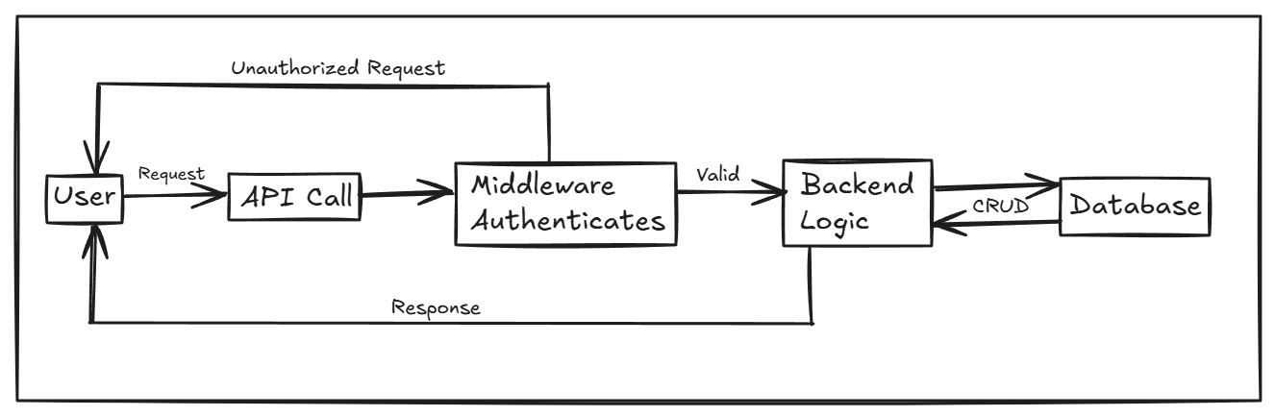

ER-Diagram
The Entity-Relationship Diagram (ERD) represents database structure, including entities like:
- Users: Stores users, victims, volunteers and admin details
- Emergencies: Stores reported emergencies
- Reports: Stores reported incidents
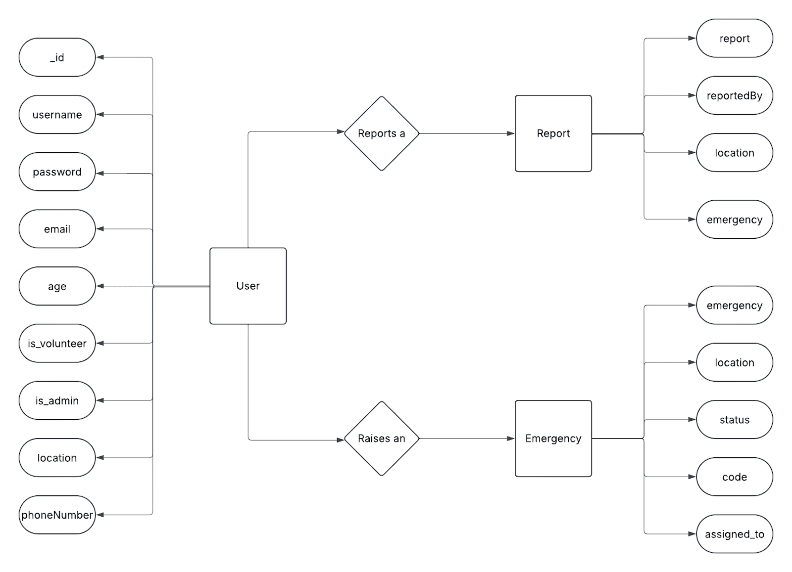
Key Features
- Automated Emergency Response: Alerts responders based on proximity
- Real-time Updates: Updates on responder locations and incident status.
- User Authentication & Role Management: Secure access for users, volunteers, and admins.
- Incident Logging & Reports: Maintains history for future analysis.
- Multi-Platform API Integration: Supports mobile, web, and IoT applications.

PRE REQUISITES
Before setting up the project, ensure you have:
- Node.js (Latest LTS version) Installed
- MongoDB Database Setup (Local or Cloud-based like MongoDB Atlas)
- Postman(App) or Thunderclient(VS Code Extension) for API Testing
- Code Editor (VS Code or Any Preferred IDE)
- Basic Understanding of JavaScript, Node.js, and MongoDB

Roles and Responsibility
The Emergency Response Network (ERN) involves three primary roles: Users, Volunteers, and Admins. Each role has distinct responsibilities to ensure efficient emergency handling and response coordination.
1. Users (Emergency Reporters)
These are individuals who report emergencies, such as victims, witnesses, or concerned citizens.
Responsibilities:
• Register and authenticate via the system.
• Report emergencies by providing details such as location, type of incident, and severity.
2. Volunteers (Responders & Emergency Personnel)
Volunteers are first responders such as medical professionals, firefighters, police officers, or trained community helpers.
Responsibilities:
• Register and authenticate in the system as verified responders.
• Receive emergency alerts based on location and availability.
3. Admins (System Managers & Authorities)
Admins oversee the system's operation, ensure data integrity, and manage users and volunteers.
Responsibilities:
- Manage system users (approve, block, or verify responders).
- Oversee emergency reports and ensure appropriate response.
Application Flow
- Users or applications send emergency requests via API.
- The system validates and logs the emergency or incident report.
- Based on severity and location, volunteers respond.
- Responders receive alerts and track incidents in real-time.
- Authorities and admins monitor ongoing incidents via API responses.

Project Structure
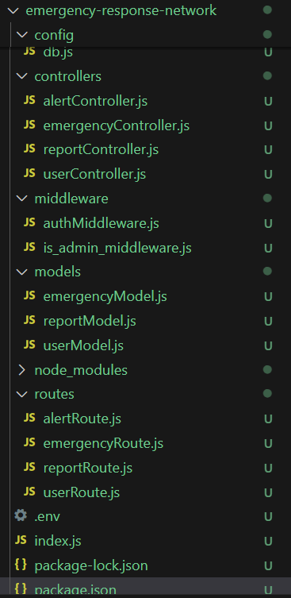

Project Setup and Configuration
- Initialize the project with Node.js & Express.js.
- Set up package.json and install necessary dependencies (express, mongoose, dotenv, jsonwebtoken, mongoose, cookie-parser, bcrypt).
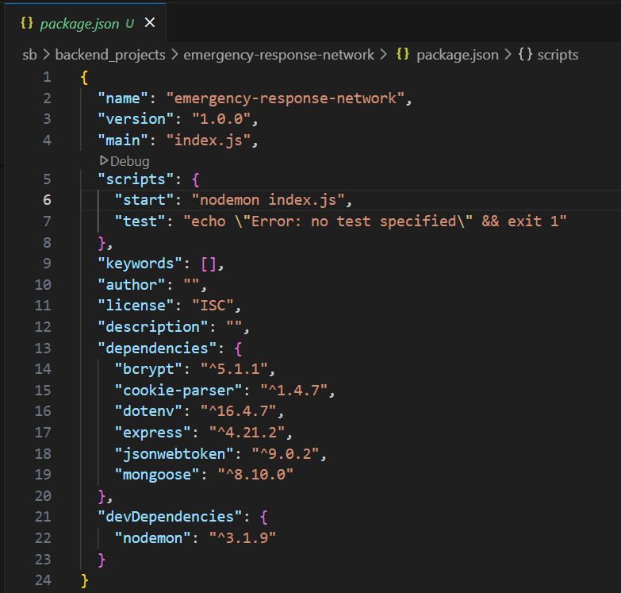

- Configure environment variables (JWT_SECRET, MONGODB_URI) and basic routing structure.

Backend Development
- Create RESTful APIs for handling emergency requests, user authentication, and incident updates.
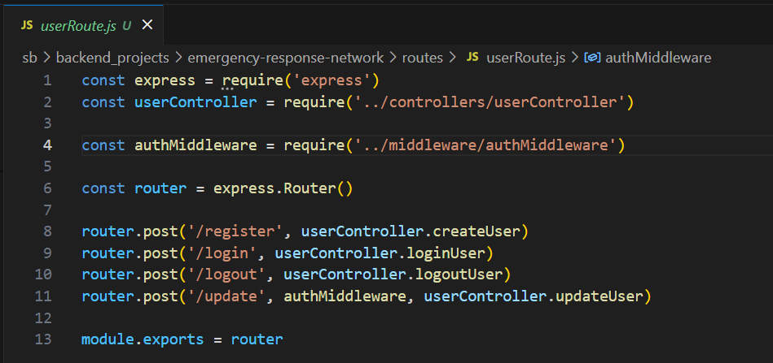
- Implement JWT-based authentication for security.
- Define controllers and middleware for data validation and request handling.

Database
- Design MongoDB schema for users, reports and emergencies.
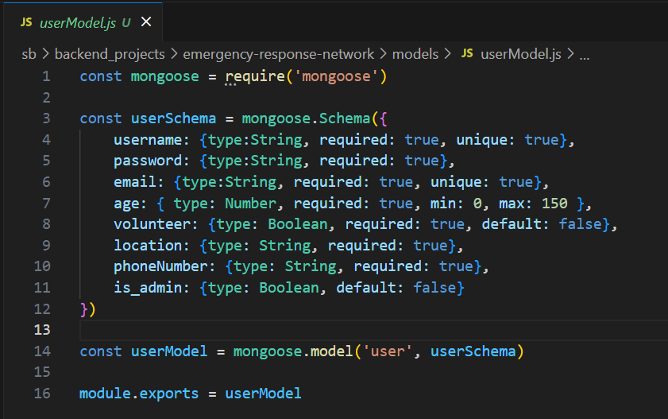
- Users Collection in MongoDB Compass
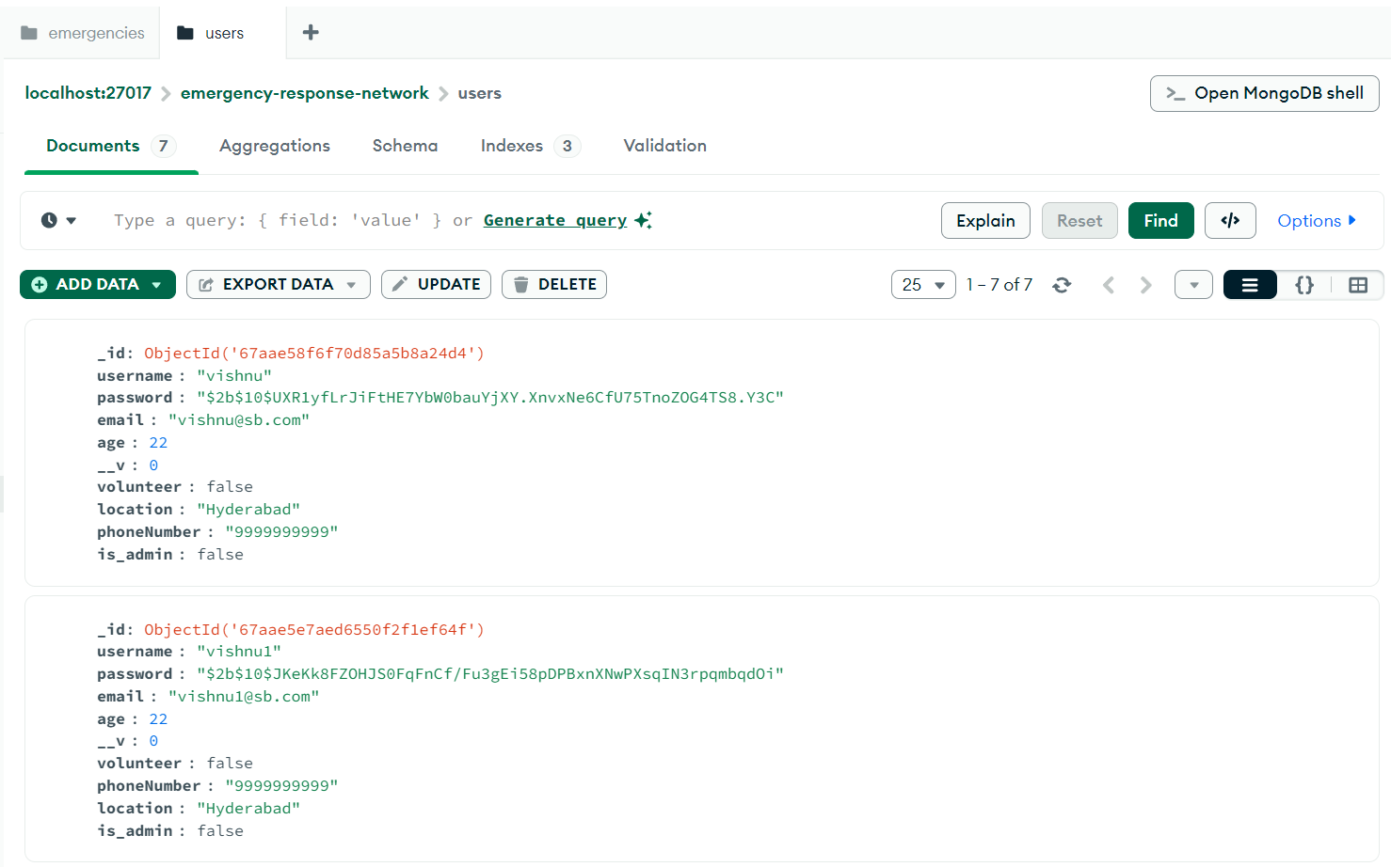
- Emergencies Collection in MongoDB Compass
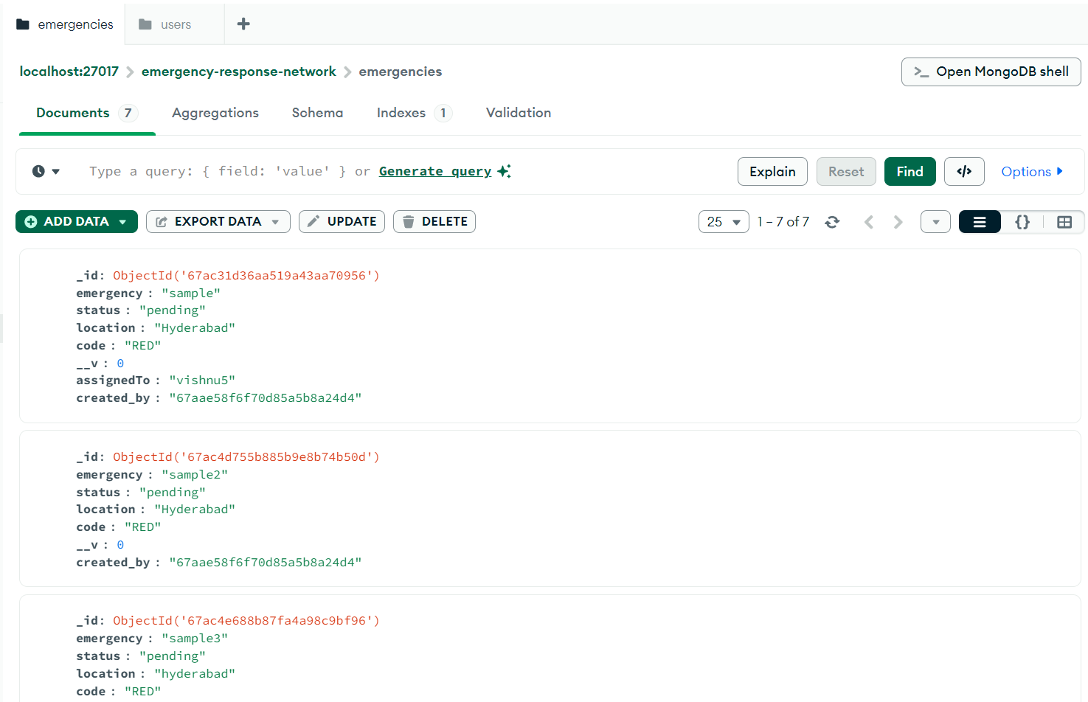

- Reports Collection in MongoDB Compass
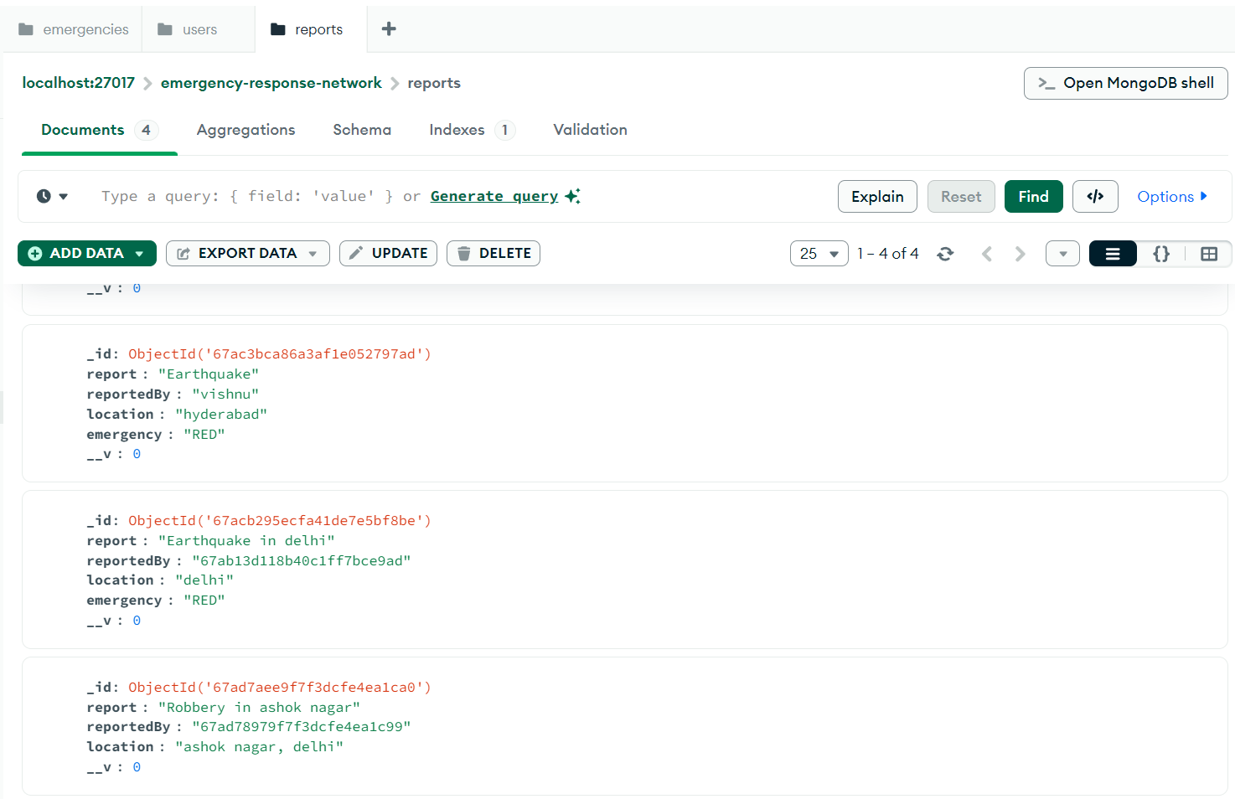

- Implement Mongoose models and database operations (CRUD).
- Set up MongoDB Atlas (if using cloud storage).

API Testing
- Use Postman(Download Application) or Thunderclient(VS Code Extension) to test API endpoints.
- Validate responses for:
  - Creating and updating reports, emergencies
  - Alerting volunteers and admins
  - Authentication and role-based access
- Debug issues and optimize performance.

Outputs (API Testing)
Register Route
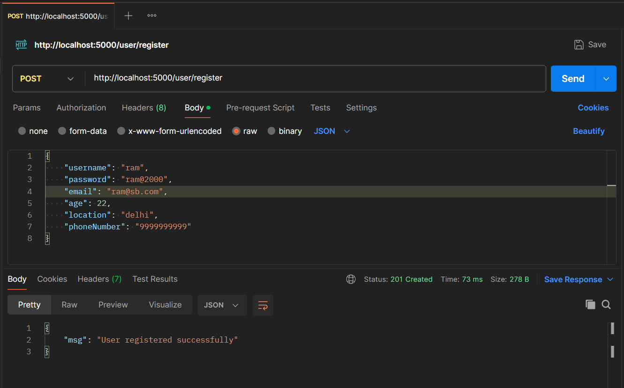
Method: POST URL: /user/register
Description: Register a new user
Login Route
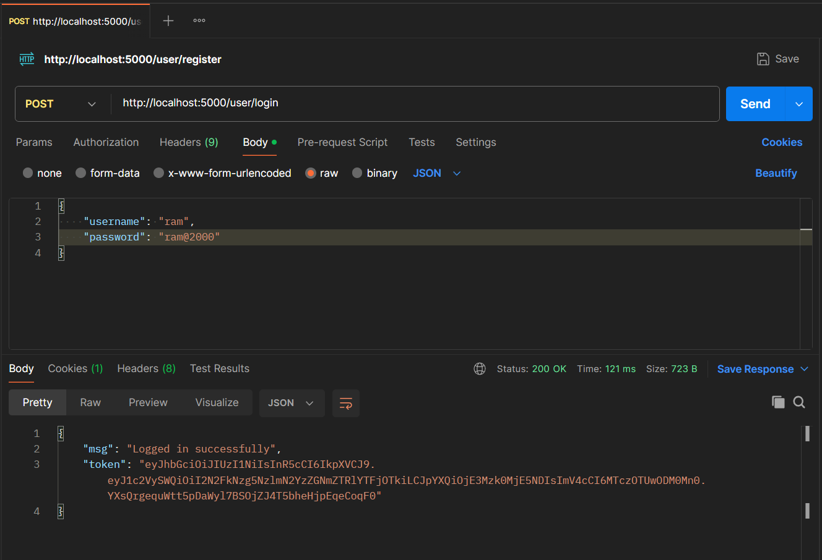
Method: POST URL: /user/login
Description: Login a user
Update Route
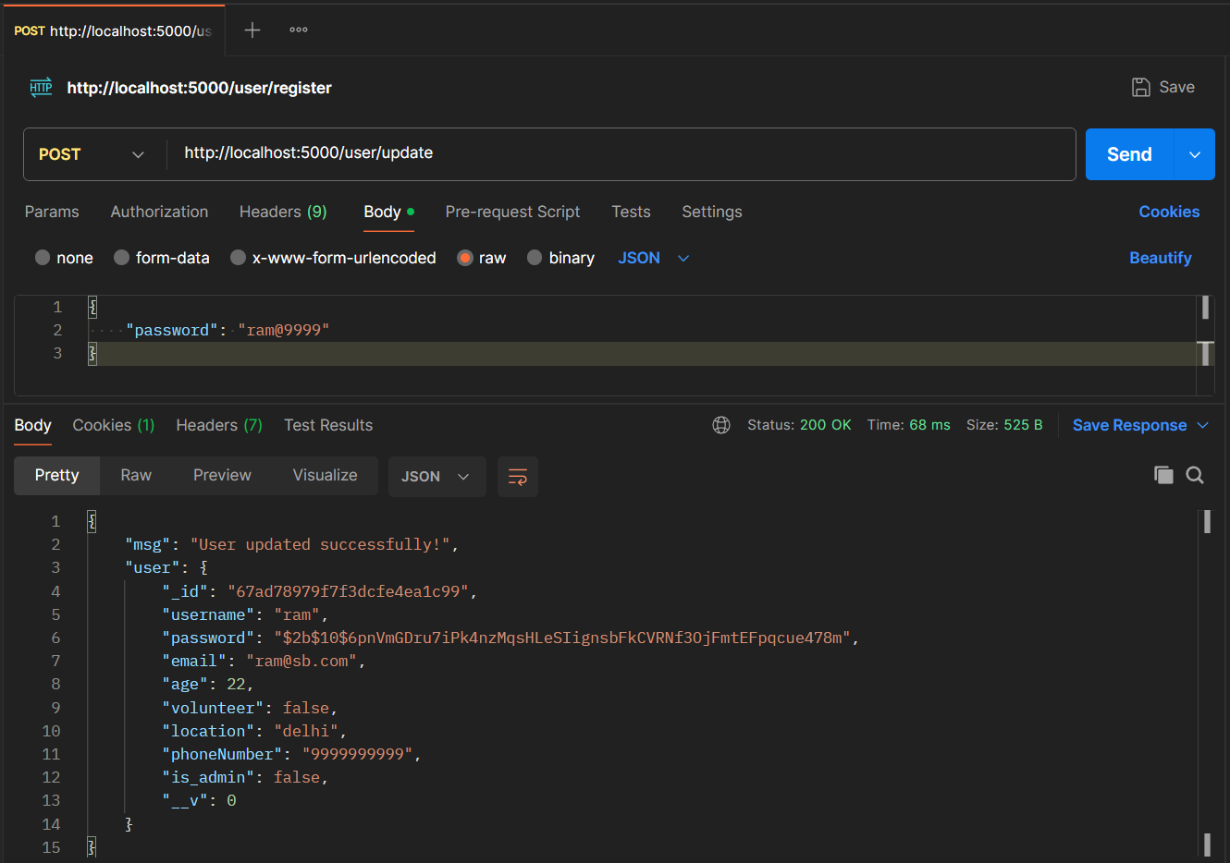
Method: POST URL: /user/update
Description: Update a user’s profile data
Logout Route
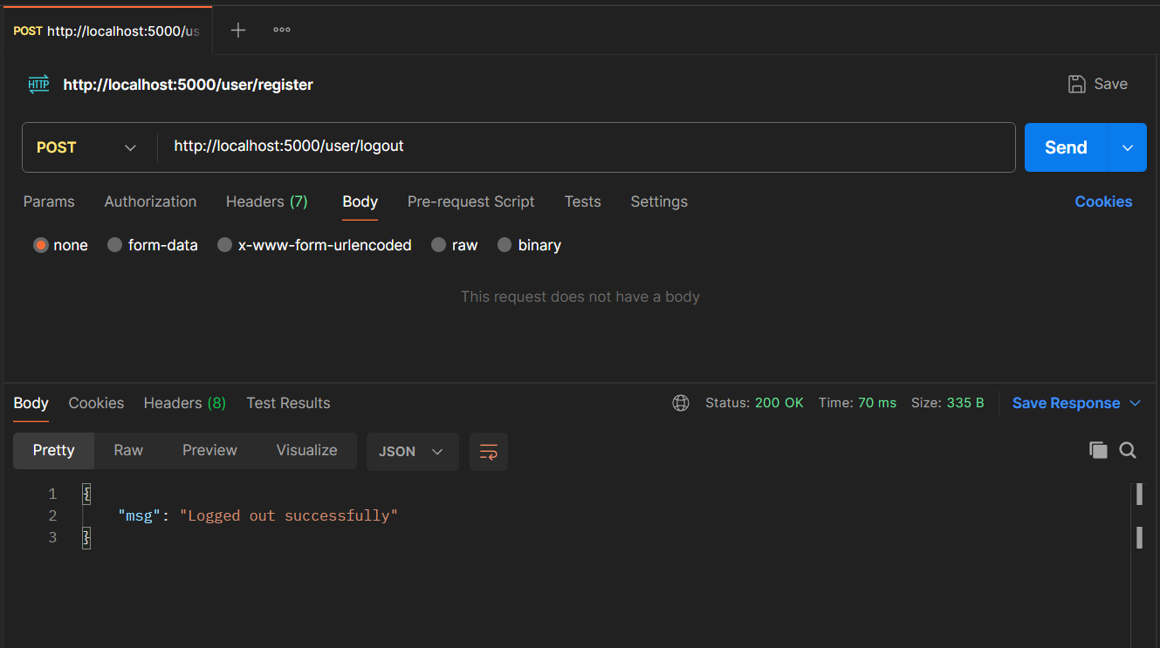
Method: POST URL: /user/logout
Description: Logout a user
Unauthorized Request (Not Logged In)
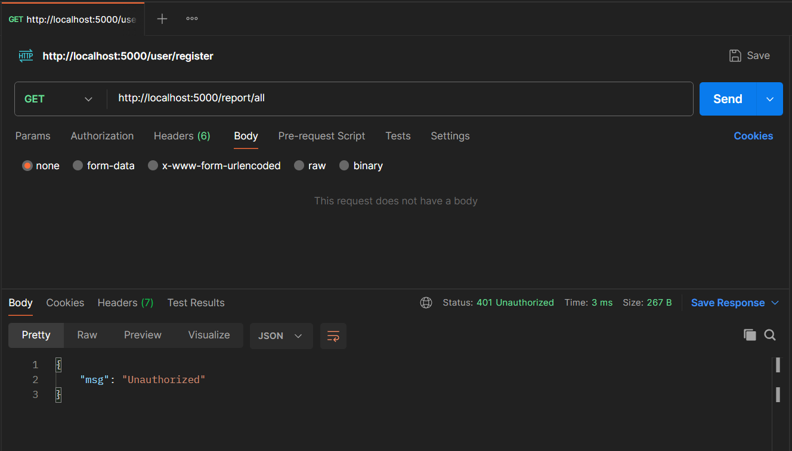
Method: GET URL: /report/all
Description: Unauthorized (when requested without logging in)
Create Report Route
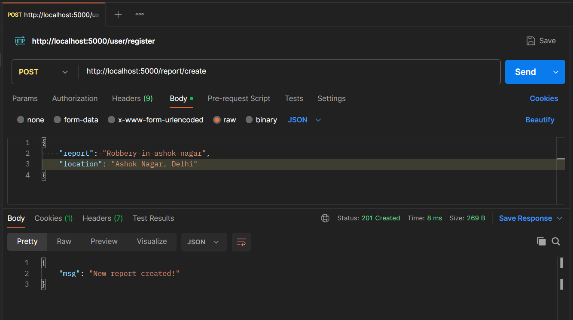
Method: POST URL: /report/create
Description: Create a new report
Get – Nearby Reports Route
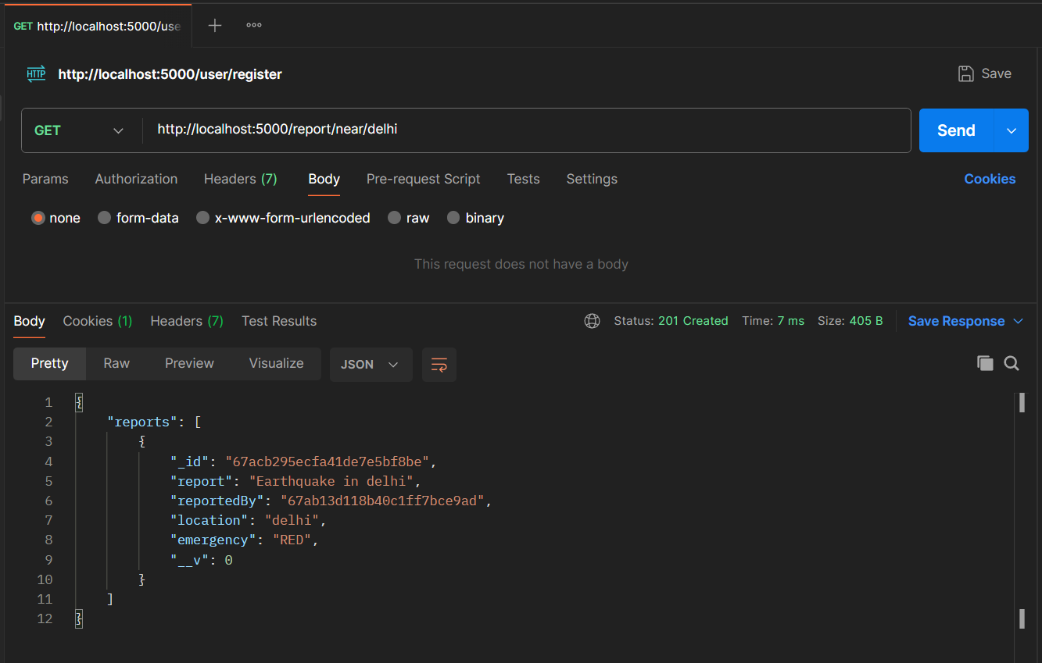
Method: GET URL: /report/near/<location>
Description: Get nearby reports(pass the location in url as shown in the image above)
Get – All Report Route
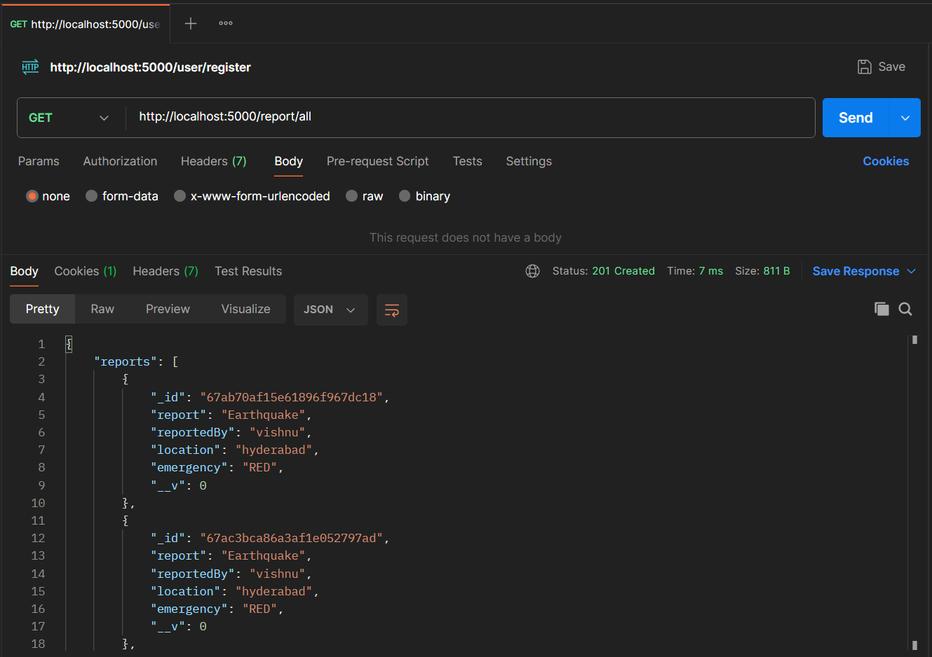
Method: GET URL: /report/all
Description: Get all reports
Filter Reports Route
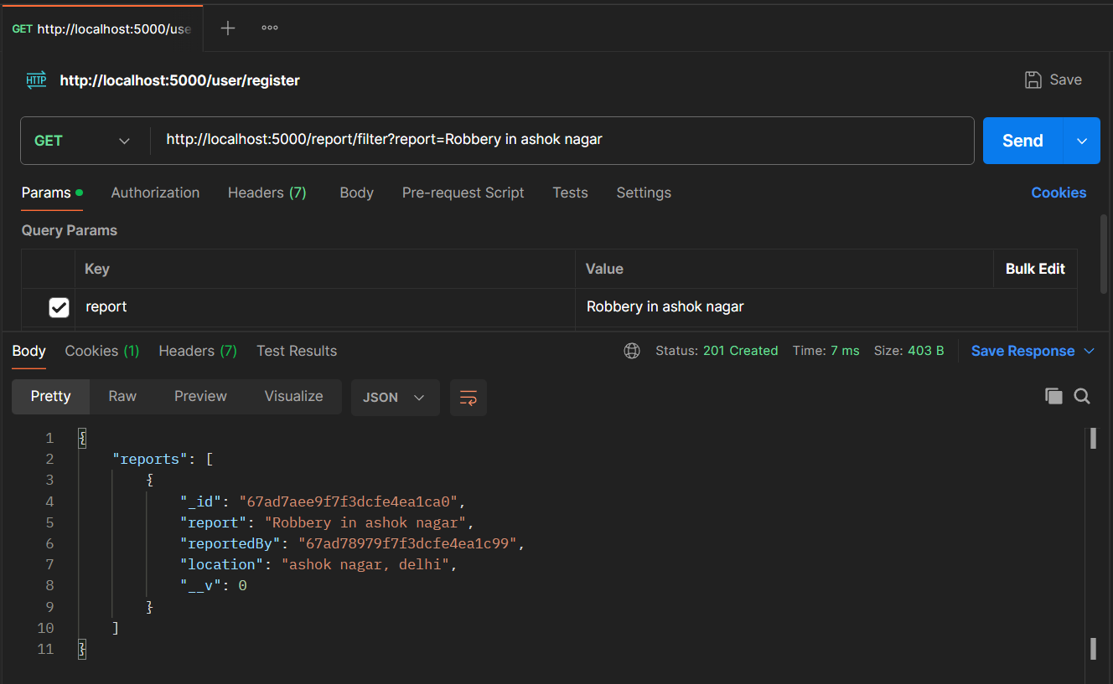
Method: GET
URL: /report/filter?<query-parameters-with-values>(see in the image above)
Description: Filter reports based on query

Create Emergency Route
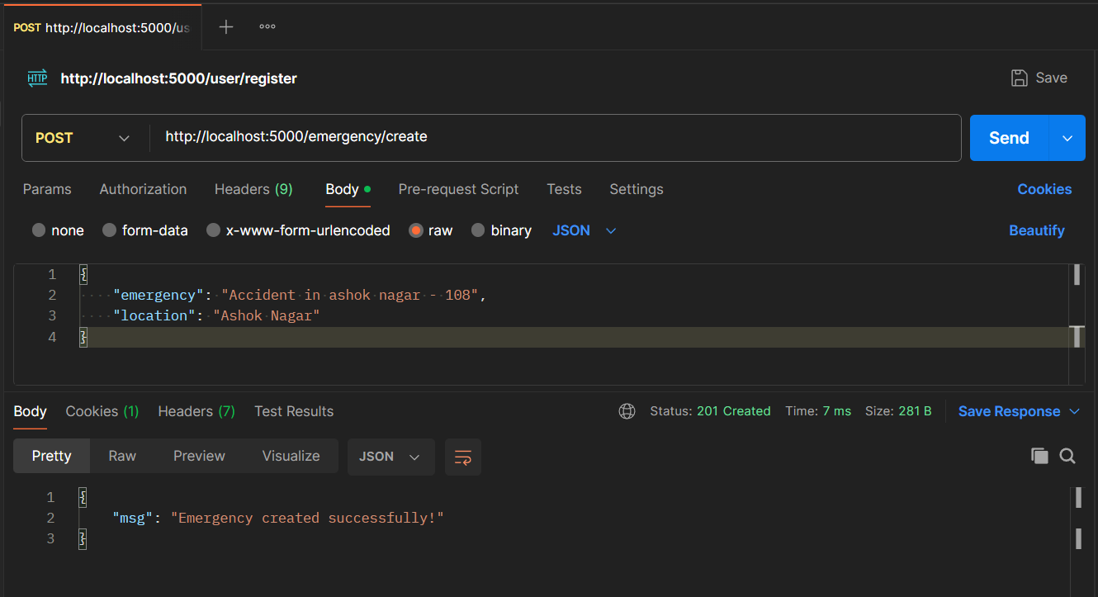
Method: POST
URL: /emergency/create
Description: Create an emergency
Update Emergency Route
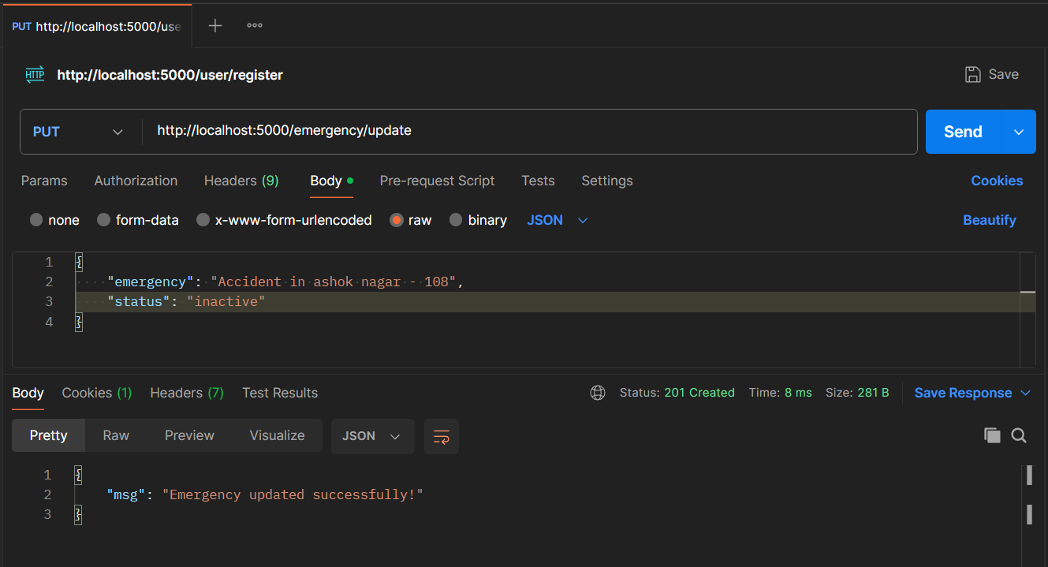
Method: PUT
URL: /emergency/update
Description: Update an emergency
Get – All Emergency Route
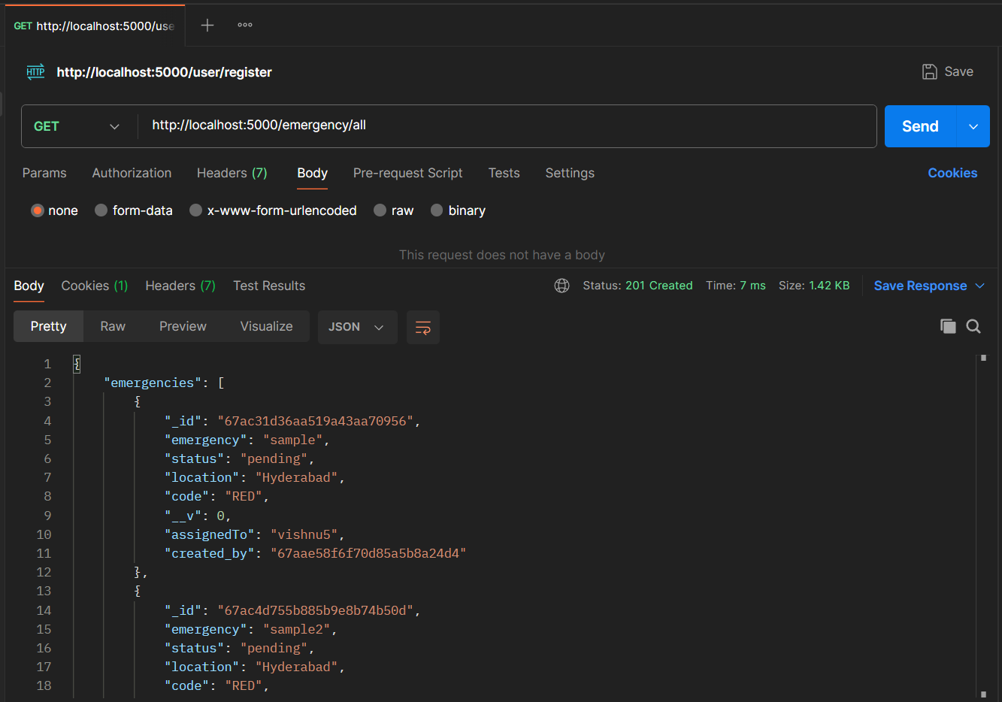
Method: GET
URL: /emergency/all
Description: Get all emergencies
Get – Nearby Emergency Route
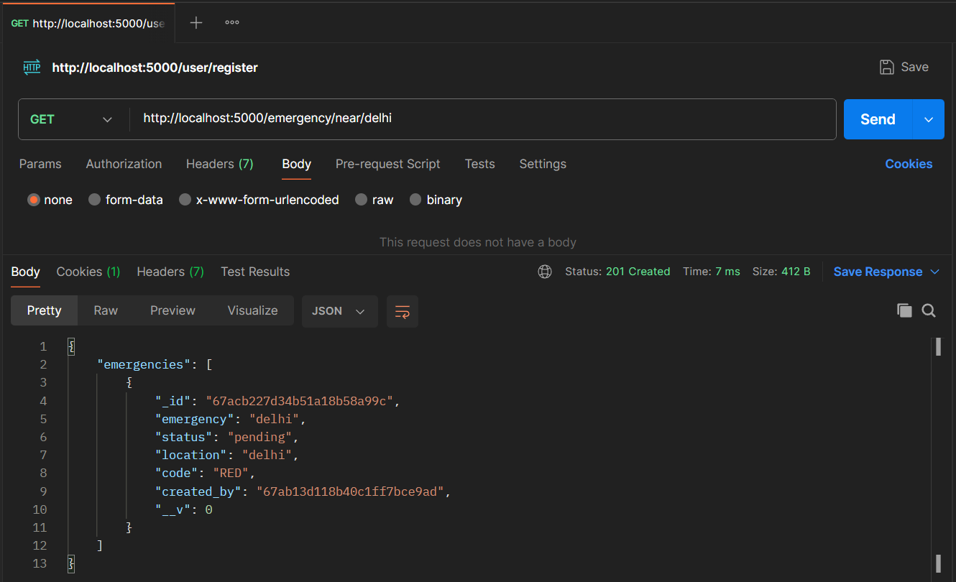
Method: GET URL: /emergency/near/<location>
Description: Get emergencies near a location; mention location in url(as shown in image)
Filter Emergency Route
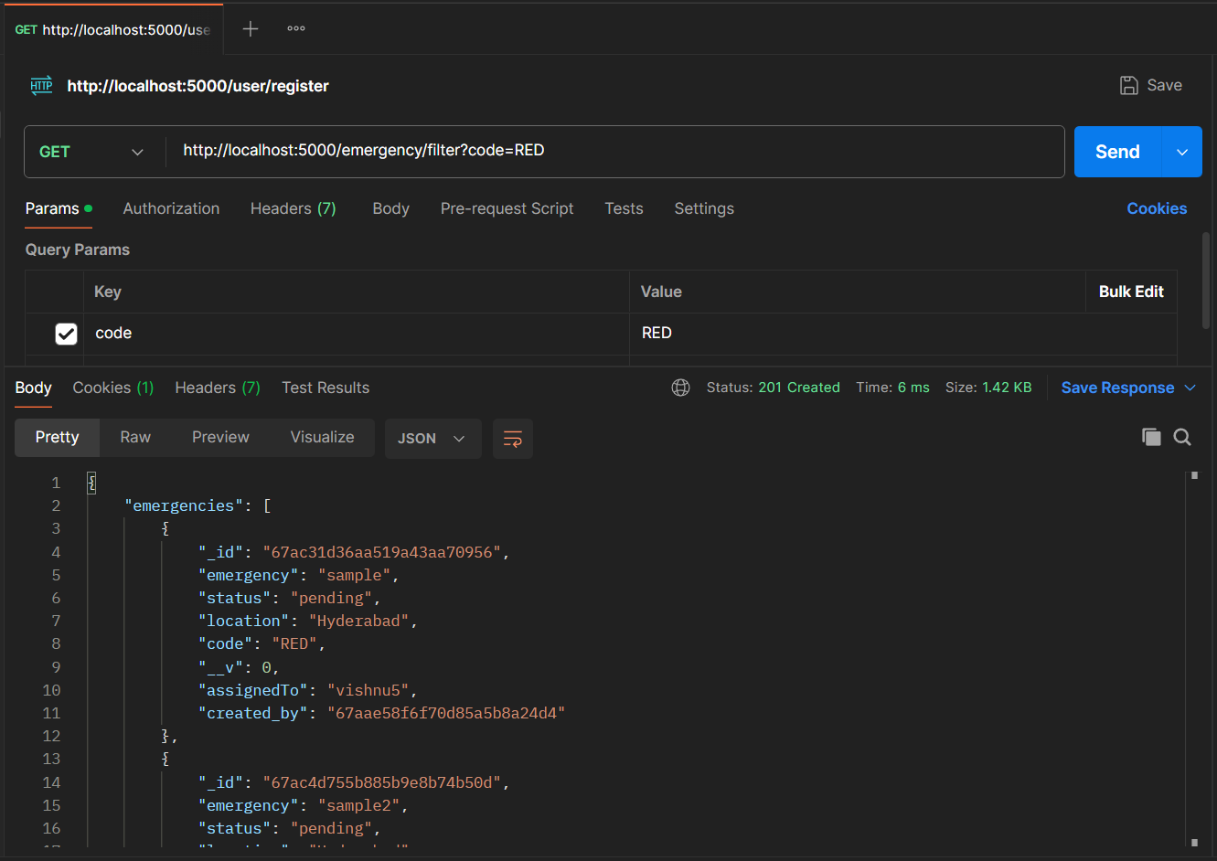
Method: GET URL: /emergency/filter?<query=value>
Description: Filter emergencies based on query parameter values(as shown in image above)
Get Alerts Route
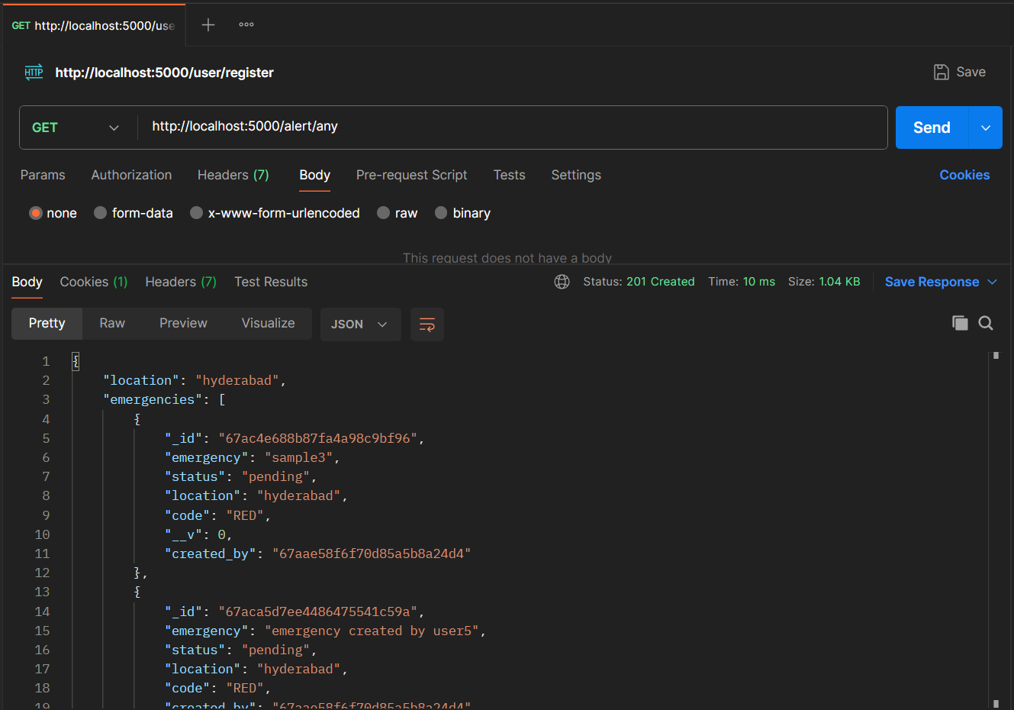
Method: GET URL: /alert/any
Description: Get all the alerts near by(based on requested user location)
Conclusion
The Emergency Response Network provides a robust backend solution for managing crisis situations effectively. With easy reporting, requesting help in emergencies, volunteers to help and secure data management, this system enhances emergency response efficiency, ensuring timely help for those in need.

